Week 1-Design Patterns and Principles

Exercise 1: Implementing the Singleton Pattern
Logger.java
public class Logger {
// Step 1: Private static instance of Logger
private static Logger instance;
// Step 2: Private constructor to prevent instantiation
private Logger() {
System.out.println("Logger instance created.");
}
// Step 3: Public method to get the single instance
public static Logger getInstance() {
if (instance == null) {
instance = new Logger(); // created only once
}
return instance;
}
// Example log method
public void log(String message) {
System.out.println("LOG: " + message);
}
}
Main.java
public class Main {
public static void main(String[] args) {
// Get Logger instance multiple times
Logger logger1 = Logger.getInstance();
Logger logger2 = Logger.getInstance();

// Log messages
logger1.log("This is the first log message.");
logger2.log("This is the second log message.");

// Verify both instances are same
if (logger1 == logger2) {
System.out.println("Only one Logger instance is used.");
} else {
System.out.println("Different Logger instances exist (Error!)");
}
}
}

OUTPUT

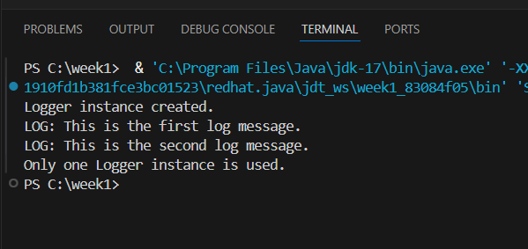
Exercise 2: Implementing the Factory Method Pattern

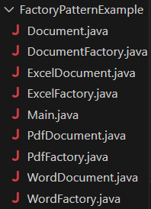

Document.java
package FactoryPatternExample;
public interface Document {
void open();
}
DocumentFactory.java
package FactoryPatternExample;
public abstract class DocumentFactory {
public abstract Document createDocument();
}

ExcelDocument.java
package FactoryPatternExample;
public class ExcelDocument implements Document {
public void open() {
System.out.println("Opening Excel document...");
}
}

ExcelFactory.java
package FactoryPatternExample;
public class ExcelFactory extends DocumentFactory {
public Document createDocument() {
return new ExcelDocument();
}
}
PdfDocument
package FactoryPatternExample;
public class PdfDocument implements Document {
public void open() {
System.out.println("Opening PDF document...");
}
}
PdfFactory
package FactoryPatternExample;
public class PdfFactory extends DocumentFactory {
public Document createDocument() {
return new PdfDocument();
}
}

WordDocument
package FactoryPatternExample;
public class WordDocument implements Document {
public void open() {
System.out.println("Opening Word document...");
}
}
WordFactory
package FactoryPatternExample;
public class WordFactory extends DocumentFactory {
public Document createDocument() {
return new WordDocument();
}}
Main.java
package FactoryPatternExample;
public class Main {
public static void main(String[] args) {
// Create a Word document using factory
DocumentFactory wordFactory = new WordFactory();
Document word = wordFactory.createDocument();
word.open();

// Create a PDF document using factory
DocumentFactory pdfFactory = new PdfFactory();
Document pdf = pdfFactory.createDocument();
pdf.open();

// Create an Excel document using factory
DocumentFactory excelFactory = new ExcelFactory();
Document excel = excelFactory.createDocument();
excel.open();
}
}

Output

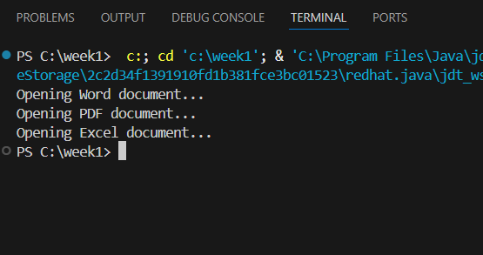d

